Investigating the Electrical Performance and Thermal Characteristic of Graphene Field Effect Transistor with Different Channel Widths

Dr. P Vimala
Professor (Associate)
Electronics and Communication
Dayananda Sagar College of Engineering, Bangalore, India ervimala@gmail.com
Tanvi Vijay
Electronics and Communication
Dayananda Sagar College of Engineering, Bangalore, India
tanvj555@gmail.com
Vishvendra Singh
Electronics and Communication
Dayananda Sagar College of Engineering, Bangalore, India
singhvishvendra700@gmail.com

Saurabh Singh
Electronics and Communication
Dayananda Sagar College of Engineering, Bangalore, India
saurabhsinghnh2@gmail.com
Sameer Gautam
Electronics and Communication
Dayananda Sagar College of Engineering, Bangalore, India
sameer.dpsranchi@gmail.com
Dr.T.S. Arunsamuel
Electronics and Communication Engineering
National Engineering College
Kovilpatti, Tamilnadu, India
arunsamuel2002@gmail.com

Abstract— In this paper, the Graphene Field Effect Transistor (GFET) is presented in terms of thermal and electrical properties by varying its channel's width. For channel widths- 1µm, 3µm, and 5µm, the electrical properties of GFET like hole density, velocity profile, I-V characteristics, and electron density, and the thermal properties like temperature profile in the respective channel region have been studied. It's been found that increasing the width of the Graphene Field-Effect Transistor leads to improvement in the overall electrical and thermal properties.
Keywords—Graphene, GFET, Current, Velocity, Temperature, electron, hole, transistor

Introduction
a layer material generally found as firmly stuffed particles in a 2D honeycomb or hexagonal cross section. A portion of the Graphene's properties incorporate high electrical properties, high warm conductivity, great optical properties, incredible compound properties, and so forth [1-8]. The counterfeit synapse depends on a side-gate graphene-field-effect-transistor (GFET) with a gate dielectric of silver gel/polarized-aptamer had been created by Chuan YuHan [9]. The presynaptic film is communicated by the gate, while the drain portrays the postsynaptic film. The GFET counterfeit synapse has been utilized to mirror an assortment of synaptic pliant qualities, counting short-term depression (STD), short-term enhancement (STE), long-term depression (LTD) and long-term potentiation (LTP) the change from present moment to long-term versatility. Affected by certain spikes applied to the presynaptic film, excitatory postsynaptic-potential-like spikes can be created at the postsynaptic film. A top gate and a back gate are utilized to tune the carrier densities in Graphene, coming about in graphene heterojunction. The proposed framework has the potential to be a helpful field-effect transistor had been created by LinglingGuo [10]. The gate voltages and off resonant circularly captivated light screen the "on" and "off" states. Our reasonable recreation opens new plan opportunities for a graphene photon controllable field-effect transistor which can likewise go about as an optical sensor. Fresh-bias photo response" alludes to a particular brief charge move instrument brought about by laser emanation. On the other side, chains of the poly particle, a charge move instrument between ester oxygen and carbonyl carbon particles is proposed by YantaoZhang [11]. Poly particle has an intermolecular dipole moment because of the charge transfer system. The age of dipole moments by a photograph set off isomerization response of a photochromic particle, which has been utilized in graphene-based photodetectors, is a lot quicker. The mobility and electron density of three-decades-long in a low-temperature titanium dioxide-channel graphene field-effect transistor area had been created by Flores-Silva [12]. Contrasted with indistinguishable SiO₂ semiconductors, we accomplish electron mobilities of up to 1877 cm2/V, and the Dirac point shows up at low gate voltages. Moreover, we use profilometry to acquire the TiO₂ surface roughness also, affirm that electron mobility is conversely relative to the channel's surface roughness. A novel field-effect transistor (FET) utilizing Graphene had been created by Seon Joo Park [13]. Graphene is a two-dimensional (2D) nanomaterial that can be utilized to evaluate the consistency of water. Specialists utilized a profoundly delicate bio test for a water contamination pointer, geosmin, to immobilize a graphene micropatterned semiconductor's surface. A great immobilized geosmin detecting bio FET (bioFET) utilizes a fluid injection procedure, the range of detection for geosmin was estimated to be between 0.01 nM - 1 M. This sensor platform could locate concentrations of 10 nM of geosmin in river water as low as well." At the core of this design was Kyung-Ho Kim's pioneering work on the GNT field-effect sensor for the detection of Gram-positive and Gram-negative bacteria [14]. A Gram stain, culture, antibody/immunosorbent assays, replicase chain (RE Chain), and genetic techniques all entail significant amounts of time and resources when used to discover an infection in the early stages. for Gram-positive and Gram-negative bacteria. The ABX-GMET platform, which includes transistors connected to chemical recognizers and novel connecting agents, is used in the microfluidics to reduce human interference and allow the devices to be self-programmed. a binding to the targeted bacteria through charge or chemical bonds The remarkable sensitivity of the ABX-GM assays allowed for a maximum allowable level of 10 CFU/mL of microbes to be detected by LOD in real time. Graphene Field-Effect Transistors were considered by Giovanni Spinelli[15], that proposed sensitivity analysis of GFP.The author tracks the rapid changes in the IDVDS field pattern characteristics Research in the parameters (i.e., the tolerances) related to the active channel of transistors (e.g., the length and width) with a 10% precision to identify out that how reliable individuals were also. The DoE method is used to study and optimize the device efficiency so that the manufacturing process can be appropriately varied to suit. bilayer nanoben-f-quantumtron field-effect transistor, the third-generation non-volatile semiconductor memory was developed by Hadi Owlia[16]. The author considering using an electrically embedded BLGNET (near-embedded source BL-EGB), which he calls an electrically embedded source GRFT (near-embedded source GRF). Lowering the electric field concentration gradients and larger bandgaps yields lower transverse field and lower gate biases. A number of digital and analog metrics benefit EESG-ERN. In terms of total frequency, the EES-GNRF has improved by 84% and by 44%. Additionally, the proposed design meets the delay and power supply (LES) delay product (PDP) requirement. sizing (SCN). The drain-induced barrier lowering (DIBL) of the electric circuit will decrease the system's short-channel effects (SCN). lipid bilayer-backed graphene field-effect transistors (GFT) encapsulated in silicon dioxide (SiO2) on glassy SiO2 (a micelle of the primary building block of soap) have developed by Dilce Ozkendir Inanc [17]. To prevent the bilayer formation, the SiO2 layer was utilized as a lipid-compatible surface. The morphology was created by thermal evaporation (TE) and pulsed electron deposition (PED). Worried flat-GFs were found to be a hundred times more sensitive than flat GFs. The increased permeability is due to the surface oxidation that results from oxidation wrinkling, which permits easy electrostatic charging. The highest-frequency field-effect transistor had been developed by Meng Tian [18]. For a variety of analytes, DNA probes have been successfully developed. The sensitivity of ave limit of an of a PNA-modified sensor is one tenth of that of a PNA probe sensitive sensor. The direct, non-quenched electrical response of a single concentration of PNA to RNA concentrations is between 0.1 and 1 millimolar to 100 micromolar, while direct, non-quenched binding of DNA to a single concentration is in the milliosmolar range. DNA probe-modified G-modified sensors lower the time to detection considerably. However, the vast majority of the research is about the channel length scaling of the GFET. The study's goal is to vary the width of the channel.

Device Structure
The GFET device structure is shown in figure 1 and has three terminals just like other general FETs, i.e., it comprises a drain, a source, and a back gate/ top gate. A graphene layer (channel) of thickness in tens of microns is inserted in the middle of the respective source terminal and the device's drain terminal. The G-FET device has three types of gate configurations: a standard GFET device can have a top gate, a global back gate, or a dual gate, i.e., it consists of both previously mentioned gates and the device structure is shown in figure 2.
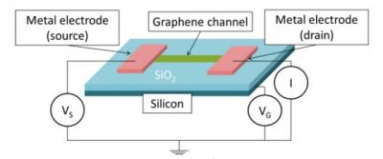

Figure 1. Schematic diagram of GFET
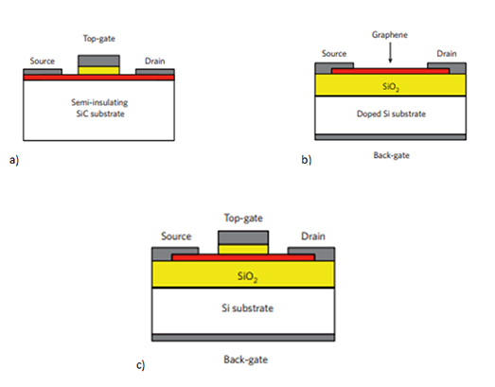

Figure 2. GFET device structure with (a) top gate, (b) back gate, and (c) dual-gate

Graphene field effect transistor (GFET) devices' fabrication is generally done on a substrate made of Si or SiO₂ by depositing the graphene layer over a wafer by a process known as the chemical vapor deposition process. At first, carbon source is being decomposed at high temperatures. Next, carbon atoms are placed on the substrate, thereby getting the desired graphene layer in its hexagonal lattice. Iron, copper, or nickel are used as a catalyst. They are used in the stages mentioned above to reduce the temperature preferred from approximately 2,500°C to nearly 1000°C. Following this, deposition of metal electrodes on Graphene is being done, and graphene channels are given the desired shape and size using lithography.

GFET tool is used for simulating and deducing the variations in the respective electrical and thermal properties of GFETs. The Nano hub version is implemented in Octave, and the simulation takes around 1 minute to run. Drift-diffusion technique is used to determine the potential difference. it also distributes the output for different features, such as carrier density, channel temperature profile, and field drift. Thus, the user can pick and choose the number of parameters according to their observations of transistor behavior. Simulation is accomplished by varying the single layer channel widths'The I-V characteristics, electron and hole density characteristics, field characteristics of the track, temperature, and velocity profile of the GFET have been simulated using the tool.
Results and Discussion

I-V Characteristics
Figure 3 indicates the drain current and drain voltage characteristics of GFET. The simulation of I-V Characteristics of GFET has been done for a channel width of 1 µm, 3 µm, and 5 µm, and it is observed that the I-V characteristics are more linear than those of the Field Effect Transistors (FET). This happens because of the presence of Graphene, which makes the channel highly conductive and nullifies any pinch-off. There is ballistic conduction of charge carriers through the drain because of the propagation of electrons with high mobility, resulting in a linearly increasing current with applied voltage. It is observed that the I-V characteristics are more linear for graphene channels of larger width.

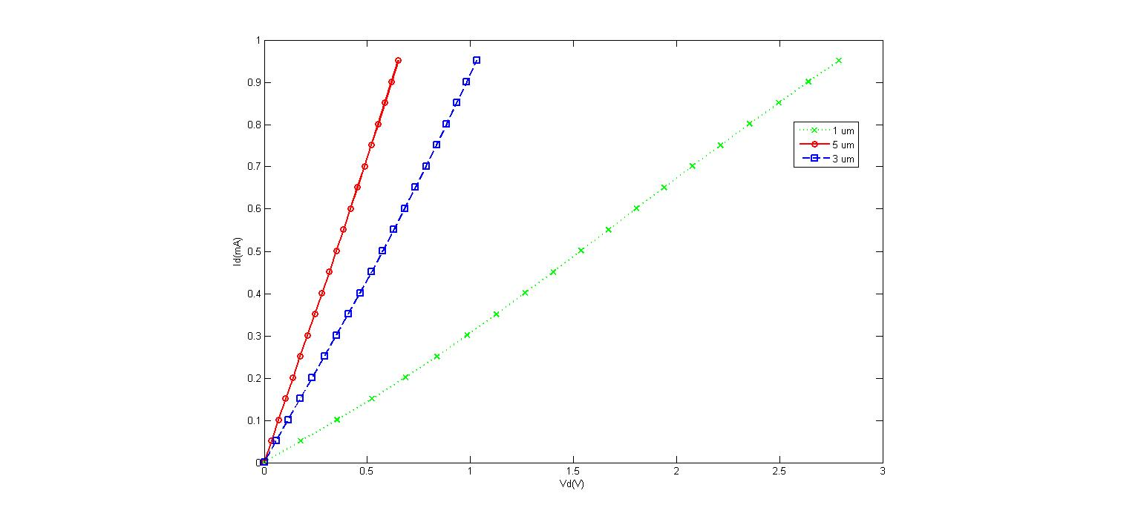
Figure 3. I_{D} vs. V_{DS} characteristics of GFET
Temperature Profile
The temperature profile of the GFET has been simulated with the channel width of 1 µm, 3 µm, and 5 µm (figure 4). It is observed that the temperature variation is linear up to the center of the channel. The electrons are inoculated from the source to the graphene channel at the center, and the electron density increases.

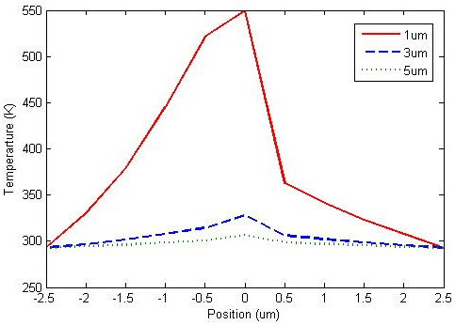
Figure 4. Temperature dependence of GFET along the channel length
Unlike in normal metal channels, the flow of electrons with high mobility through the graphene channel causes an increase in temperature because of the highly conducting nature of Graphene and, as a result of which the temperature varies linearly around this central position. As we advance from the center to the near end of the channel, the electron concentration becomes almost constant. The temperature of the graphene channel decreases subsequently to room temperature. At the end of the track, the temperature falls linearly to the ideal temperature. It is also observed that for graphene channels of smaller width, the increase in temperature is significant, whereas, for media of larger width, the temperature rise is slight.
Electron Density
For electron density characteristics of the GFET channel, electron density increases linearly with an increase in position from the origin (figure 5), except for certain parts in the track where it becomes fixed. The electrons get clogged at the end of the way, the total density of the electrons from that particular position of the channel becomes fixed. The simulation has been performed for graphene channels of width 1 µm, 3 µm, and 5 µm, and the curve formed has been observed to find that for graphene channels of small width, the electron density is greater at the channel end, and for graphene channels of larger width, the electron density is less at the channel end.

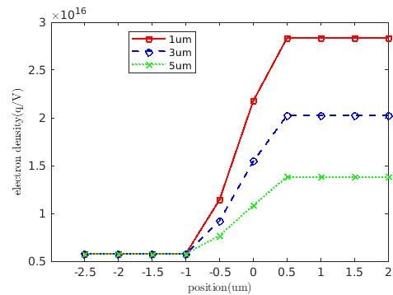

Figure 5. Electron density profile of GFET along the channel axis
Hole Density
It also observed that the increase in electron density decreases the channel's hole density as each electron occupies a hole at the track (figure 6). The electrons get clogged at the end of the channel, so no more spots are occupied at that position, in which density of hole becomes fixed. The simulation has been performed for graphene channels of width 1 µm, 3 µm, and 5 µm, and the curve formed has been observed to find that for graphene channels of small width, the hole density is lesser at the channel end, and for graphene channels of larger width, the hole density is more at the channel end.
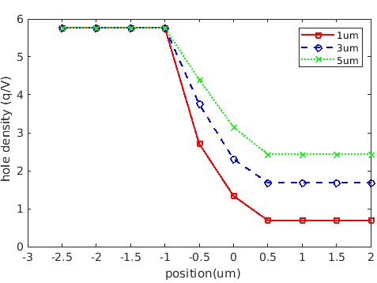
Figure 6. Hole density profile of GFET along the channel axis

Velocity Profile
The velocity profile of GFET has been simulated along the channel for widths of 1 µm, 3 µm, and 5 µm. It is observed that when we move from the center of the channel towards the near end, there is a gradual increase in the velocity of electrons to a peak value and, at the end there is a sharp increase in the velocity. The electrons get clogged at the channel end and try to reach the drain region quickly. Consequently, in this region, there is a steep increase in the velocity of electrons which results in their collision. For channels of larger width, the velocity of charge carriers increases more sharply as compared to the channels of smaller width, because electrons get enough space to move
to the drain region for graphene channels of larger width.
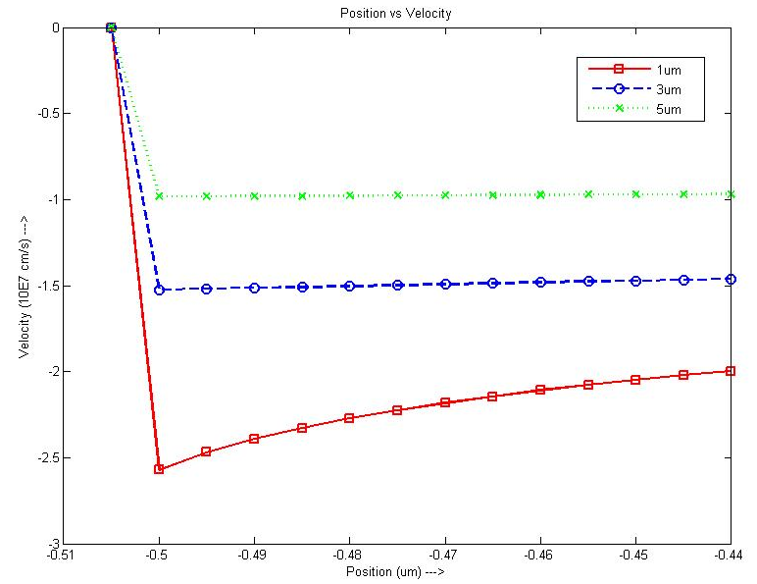

Figure 7. Velocity profile of GFET along channel length

Table I

At 1 um distance

Parameter | Channel Length
Parameter | 1 um | 3 um | 5 um
Temperature (K) | 341.941 | 302.37 | 296.965
Hole density  (cm⁻²) | 6.93744e+14 | 1.68543e+15 | 2.43358e+15
Electron density  (cm⁻²) | 2.83395e+16 | 2.02412e+16 | 1.38234e+16

Inference
The table describes the behavior of parameters (namely Temperature, Hole density and Electron density) with varying channel length at a fixed position of 1um for Graphene Field Effect Transistor. The temperature is observed to decrease with increasing channel length. The hole density is observed to increase with increasing channel length whereas the electron density being inversely proportional to hole density decreases with increasing channel length.

Conclusion
This brief has presented the performance analysis of the Graphene Field Effect Transistor (GFET) in terms of thermal and electrical properties by varying width of its channel (1µm, 3µm and 5µm). It has been inferred from the presented results that as the channel length is scaled down, there is a notable improvement in electrical characteristics which may improve the sensitivity of the device. Hence, the GFET device is highly suitable for bio sensing applications.

REFRENCES

[1] Y.-M. Lin, J. Appenzeller, C. Zhihong , Z.-G. Chen, H.-M. Cheng, P. Avouris, "High-performancedual-gate carbon nanotube FETs with 40-nm gate length", IEEE Electron Dev. Lett., Vol. 26, No. 11, 2005.
[2] K. S. Novoselov, A. K. Geim, S. V. Morozov, D. Jiang, Y. Zhang, S. V. Dubonos, I. V. Grigorieva, and A. A. Firsov, "Electric Field Effect in Atomically Thin Carbon Films", Science, Vol. 306, pp. 666-669, October 2004.
[3] Y.Zhang, Y.-W. Tan, H. L. Stormer, and P. Kim, "Experimental observation of the quantum Hall effect and Berry's phase in graphene", Nature, Vol. 438, pp. 201-204, November 2005.
[4] Cervenka, J. et al. Graphene field effect transistor as a probe of electronic structure and charge transfer at organic molecule-graphene interfaces, Nanoscale 7, 1471–1478, 2014.
[5] Batzill, M. The surface science of Graphene: metal interfaces, CVD synthesis, nanoribbons, chemical modifications, and defects. Surf. Sci. Rep. 67, 83–115, 2012.
[6] Kumar, B. et al. The role of external defects in chemical sensing of graphene field-effect transistors. Nano Lett. 13, 1962–1968, 2013.
[7] N. G. H and V. P, "Prospects of Two-Dimensional Graphene as Field Effect Transistor for future electronic devices," 2020 2nd PhD Colloquium on Ethically Driven Innovation and Technology for Society (PhD EDITS), Bangalore, India, 2020, pp. 1-2, doi: 10.1109/PhDEDITS51180.2020.9315318.
[8] Nayana G. H., Vimala P, "Monolayer and bilayer graphene field effect transistor using Verilog-A", International Journal of Reconfigurable and Embedded Systems (IJRES), 10 (1) 56-64, 2021.
[9] Han, C. Y., Li, Y., Zhang, Z. X., Liu, W. H., Li, X., Guo, X., ... & Lin, Q. (2021). An artificial synapse based on graphene field-effect transistor with silver gel/polarized-aptamer gate. Organic Electronics, 106118.
[10] Guo, L., Zhang, Q., & Chan, K. S. (2020). A dual-gate field-effect transistor in graphene heterojunctions. Superlattices and Microstructures, 106778.
[11] Zhang, Y., Yuan, Y., Cao, G., Han, C., Li, X., Wang, X., & Liu, W. A fresh-bias photoresponse of graphene field-effect transistor: An electrical tunable fast dipole moment generation. Carbon, 173, 322-328.
[12] Flores-Silva, P. A., Borja-Hernández, C., Magaña, C., Acosta, D. R., Botello-Méndez, A. R., & Serkovic-Loli, L. N. (2020). Graphene field effect transistors using TiO2 as the dielectric layer. Physica E: Low-dimensional Systems and Nanostructures, 124, 114282.
[13] Park, S. J., Seo, S. E., Kim, K. H., Lee, S. H., Kim, J., Ha, & Kwon, O. S. (2020). Real-time monitoring of geosmin based on an aptamer-conjugated graphene field-effect transistor. Biosensors and Bioelectronics, 112804.
[14] Kim, K. H., Park, S. J., Park, C. S., Seo, S. E., Lee, J., Kim, & Kwon, O. S. (2020). High-performance portable graphene field-effect transistor device for detecting Gram-positive and negative bacteria. Biosensors and Bioelectronics, 167, 112514.
[15] Spinelli, G., Lamberti, P., Tucci, V., Pasadas, F., & Jiménez, D. (2020). Sensitivity analysis of a Graphene Field-Effect Transistors by means of Design of Experiments. Mathematics and Computers in Simulation.
[16] Owlia, H., & Fazli, R. (2020). Bilayer graphene nanoribbon field-effect transistor with electrically embedded source-side gate. Superlattices and Microstructures, 142, 106525.
[17] Inanc, D. O., Celebi, C., & Yildiz, U. H. Lipid bilayer on wrinkled-interfaced graphene field effect transistor. Materials Letters, 284, 128998.
[18] Tian, M., Qiao, M., Shen, C., Meng, F., Frank, L. A., Krasitskaya & Wang, J. (2020). Highly-sensitive graphene field effect transistor biosensor using PNA and DNA probes for RNA detection. Applied Surface Science, 527, 146839.

